   | Internat. Society of Ultrasound in Obstet. & Gynecol.  European Association of Perinatal Medicine  Polish Ultrasound Society in Ob&Gyn | 


ULTRASONOGRAFIA GINEKOLOGICZNA
Torun, Poland

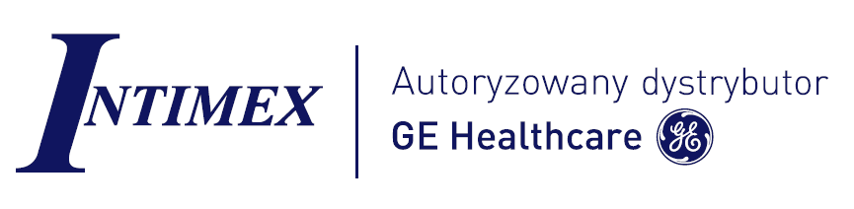
May 14, 2015

Organizers: Mariusz Dubiel and Marek Pietryga

Place: Hotel Bulwar, Torun, Poland

May 14 th Lectures
08.00-8.50 Registration
8.50-9.00 Introduction M. Dubiel, M. Pietryga
Chairmen: M. Zikan, M.Dubiel

9.00-9.45 Ultrasound examination of the cervix and staging of cervical cancer M. Zikan

9.45-10.30 Abdominal ultrasound for emergency cases and gynecological
cancer staging M. Zikan
10.30 – 11.00 Miniinvasive interventions under ultrasound guidence
in gyneocological oncology M. Zikan

11.00 – 11.30 Ultrasound examination of the endometrium and staging
of endometrial cancer M. Zikan

11.30 –12.00 Sensitivity and specificity of different ultrasound based algorithms
used for differentiatinf between benign and malignant pelvic masses M. Zikan
12.00-12.30 Ultrasound screening for gynecological malignancies M. Zikan
12.30-13.00 Metastatic pelvic tumors and their ultrasound features M. Zikan

13.00 – 13.30 Live presentation M. Zikan
13.30 – 14.00 Live presentation R. Mattern

14.00 - 15.00 Lunch

Lecturers:

Mariusz Dubiel Professor Bydgoszcz
R. Mattern Salzburg
Marek Pietryga Professor Poznan
Michal Zikan Professor Prague

