   | Internat. Society of Ultrasound in Obstet. & Gynecol.  European Association of Perinatal Medicine  Polish Ultrasound Society in Ob&Gyn | 


Ultrasound and Clinical Decisions
Torun, Poland

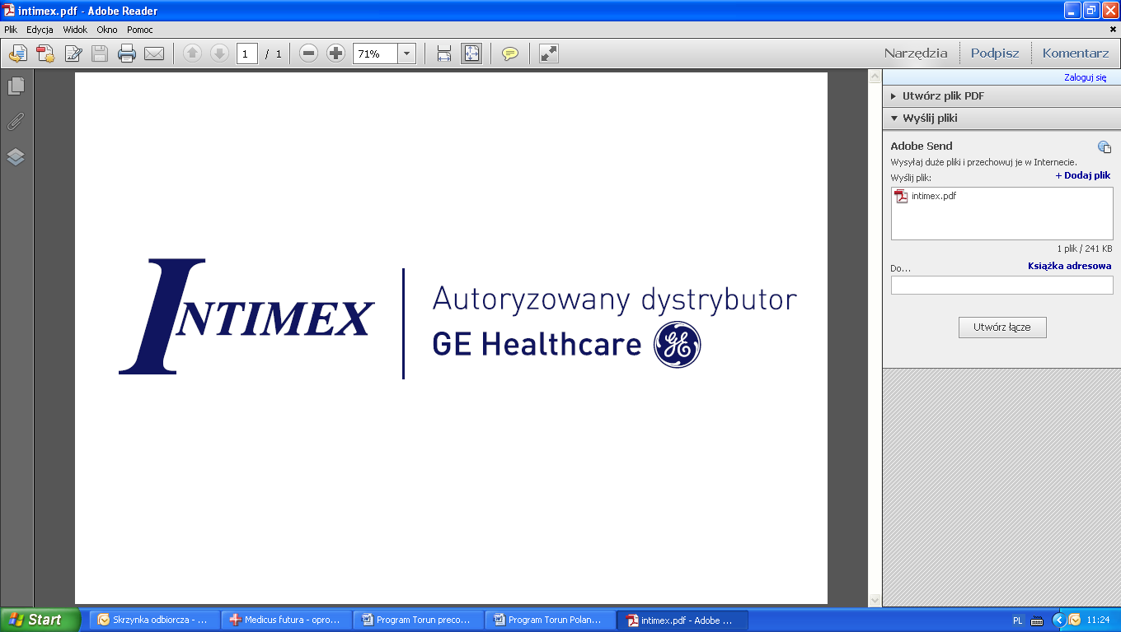
May 15-16, 2015

Organizers: Mariusz Dubiel and Marek Pietryga
Place: Hotel Bulwar, Torun, Poland

May 15 th Lectures
08.00-8.50 Registration
8.50-9.00 Introduction M. Dubiel, M. Pietryga
1 session: Chairmen: K. Marsal and T. Kiserud
9.00 – 9.45 Doppler ultrasound in the clinical management of very preterm IUGR
(TRUFFLE and Lund studies). K. Marsal
9.45 – 10.30 Fetal growth velocity: an additional indicator for perinatal outcome T. Kiserud
10.30 – 11.00 Comparison of fetal cardiac strain and venous blood velocities S. Gudmundsson
11.00 –12.00 Future In Ultrasound. Live presentation of Voluson E10 R. Mattern, M. Heinzinger
12.00 – 12.15 Ductus venosus blood velocity waveform - systolic velocity is more predictive of outcome
than is that in diastole S. Gudmundsson
12.30 –13.00 Longitudinal Doppler monitoring T. Kiserud
13.00 – 13.30 Multiple pregnancy - clinical decision-making M. Ropacka
13.30 – 14.30 Lunch

2 session: Chairmen: S. Gudmundsson and M. Pietryga
14.30– 15.00 Placenta accreta - clinical decision-making G. Bręborowicz
15.00 – 15.30 How to avoid pitfalls in Doppler ultrasound in order to prevent erroneous clinical decisions
in high-risk pregnancies K. Marsal
15.30 – 16.00 Ultrasound screening and the 3D-ultrasound estimation of fetal weight for detection
and mangement of large fetuses. K. Marsal
16.00 – 16.30 Increased Nuchal Translucency - what should we offer B. Czuba
16.30 – 17.00 Intrapartum ultrasound - tool or toy? W. Cnota
17.00 – 17.30 What does fetal brain sparing tell us? S. Gudmundsson
17.30 – 18.00 Cerebropacental ratio: a monitoring option T. Kiserud
19.00 Get-together party

May 16th Lectures

3 Session: Chairmen: C. von Kaisenberg and M. Pietryga

9.00 – 9.30 Second trimester standard planes and the diagnosis of fetal anomalies C. von Kaisenberg
9.30 – 10.00 Sonographic monitoring and timing of delivery in gastroschisis W. Cnota
10.00 – 10.30 IUGR fetuses - how to monitor them and when to deliver? W. Cnota
10.30 – 11.00 Current list of Trisomy 21st soft markers in the second trimester B. Czuba
11.00 – 11.30 Screening for Pre-ecclampsia: biochemically and by uterine artery Doppler C. von Kaisenberg
11.30 – 12.00 Abnormal early pregnancy - ultrasound in clinical decisions P. Sieroszewski
12.00 – 12.30 Update of 11-13+6 weeks including non-invasive Testing and emphasis on screening
for pre-ecclampsia C. von Kaisenberg
12.30– 13.00 Management in pregnancy with abnormal NT and normal karyotype D. Borowski
13.00 – 13.30 Genetics and Maternal-Fetal Hemodynamics – clinical aspects P. Węgrzyn

13.30 – 14.00 Lunch
4 session: Chairmen: J. Brazert and M Dubiel

14.00 – 15.00 Fetal intra-uterine therapy and clinical decisions K. Szaflik
14.30 – 15.00 Insufficiency or fetal circulation – diagnosis and treatment A. Wloch
15.00 – 15.30 Cardiologic evaluation of fetuses with TTTS – diagnosis and treatment K. Janiak
15.30 – 16.00 Fetal arrhythmias – diagnosis and treatment A. Wloch
16.00 – 17.00 Normal or abnormal fetal heart? Case reports A. Wloch and K. Janiak
17.00– 17.15 Closing remarks and comments M. Dubiel
Lecturers:
Dariusz Borowski Professor Bydgoszcz
Jacek Brązert Professor Poznań
Grzegorz Bręborowicz Professor Poznan
Wojciech Cnota MD, PhD Katowice
Bartosz Czuba MD, PhD Katowice
Mariusz Dubiel Professor Bydgoszcz
Saemundur Gudmundsson Professor Malmo
Michael Heinzinger Salzburg - Zipf
Katarzyna Janiak Reader in Perinatal Cardiology Lodz
Constantin v Kaisenberg Professor Hannover
Torvid Kiserud Professor Bergen
Karel Marsal Professor Malmo
Roland Mattern Salzburg - Zipf
Marek Pietryga Professor Poznan
Mariola Ropacka Professor Poznań
Piotr Sieroszewski Professor Lodz
Krzysztof Szaflik Professor Lodz
Piotr Węgrzyn MD, PhD Warsaw
Agata Włoch MD, PhD, Reader in Perinatal Cardiology Katowice

